AS02 -

Functionality
- You can change various fields of the asset master data even after the asset master is created.

Scenario
Certain assignments during the life cycle of an asset change frequently, and therefore a record should be kept of the changes, both for reporting and for valuation needs. Examples are the assignment of an asset to a cost center, or multiple-shift usage of an asset during a certain time period.
You can store the following assignments with different time intervals:
1) Cost center 2) Plant 3) Cost order
Data is stored in an unbroken sequence showing the exact day, with a "valid from" and "valid to" date. When you access a master record, the time-dependent data valid for the date of the request is displayed. If the assignment is different in other time periods, this is designated by a history indicator after the field. Using the "Field breakdown" function, you display the entries for a given field at the different intervals.

Requirements
None.

Menu Path | Accounting → Financial Accounting → Fixed Assets → Asset → Change → AS02 - Asset
Transaction Code | AS02

1. Double Click on AS02 - Asset

Change Asset: Initial screen

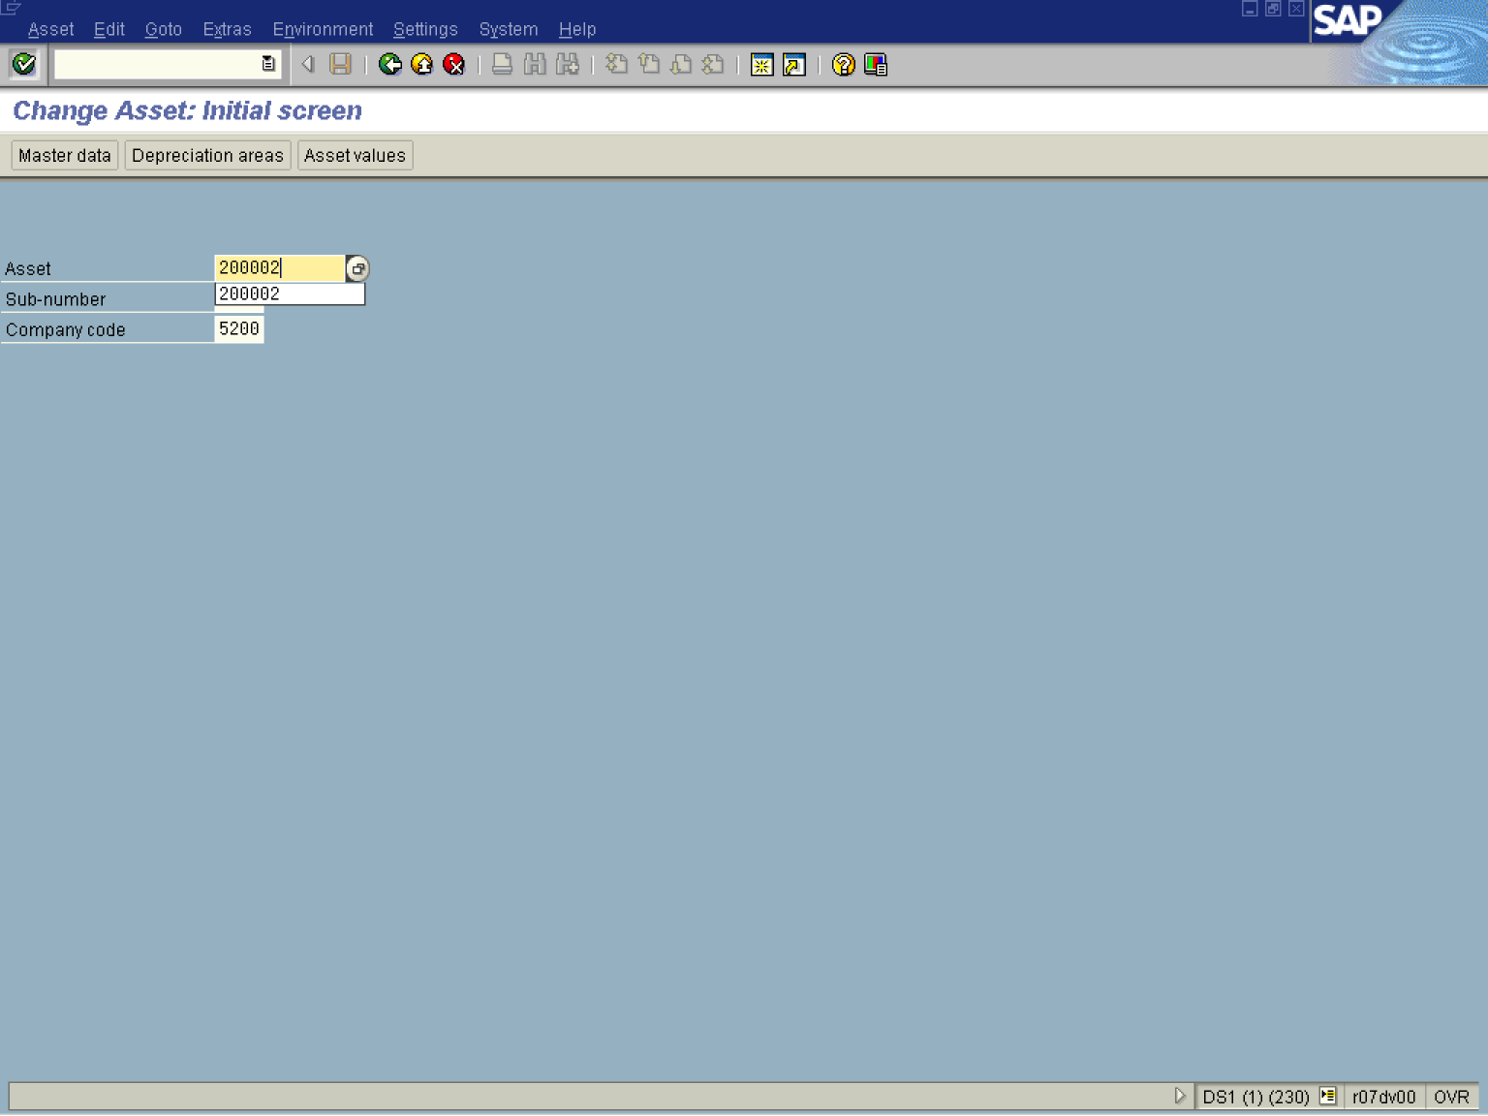

2. Update the following fields:

Field Name | Field Description | Values
Asset Number | This is the number which, together with the asset sub-number, identifies a fixed asset in Asset Accounting. | Example: 5217000
3. Click the Enter button.

Change Asset: Master data

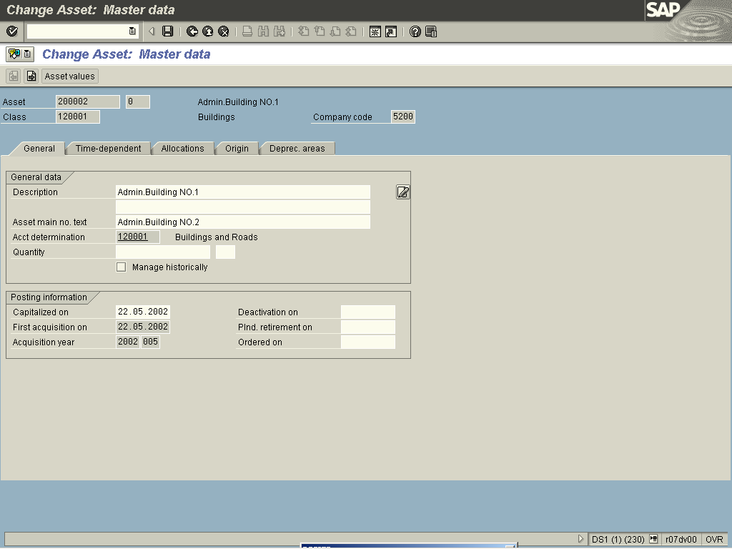

4. Update the following fields:

Field Name | Field Description | Values
Description | Enter a name for the asset in this field. | Example: Admin.Building NO.1
Asset main no. text | In this field, you can enter any desired name for an asset main number. The text is then used, for example, in reporting, and in the display values transaction when accessing totals per asset main number. | Example: Admin.Building NO.2

5. Click Enter to validate the entry.
6. Click on the Time-dependant data tab

Change Asset: Master data

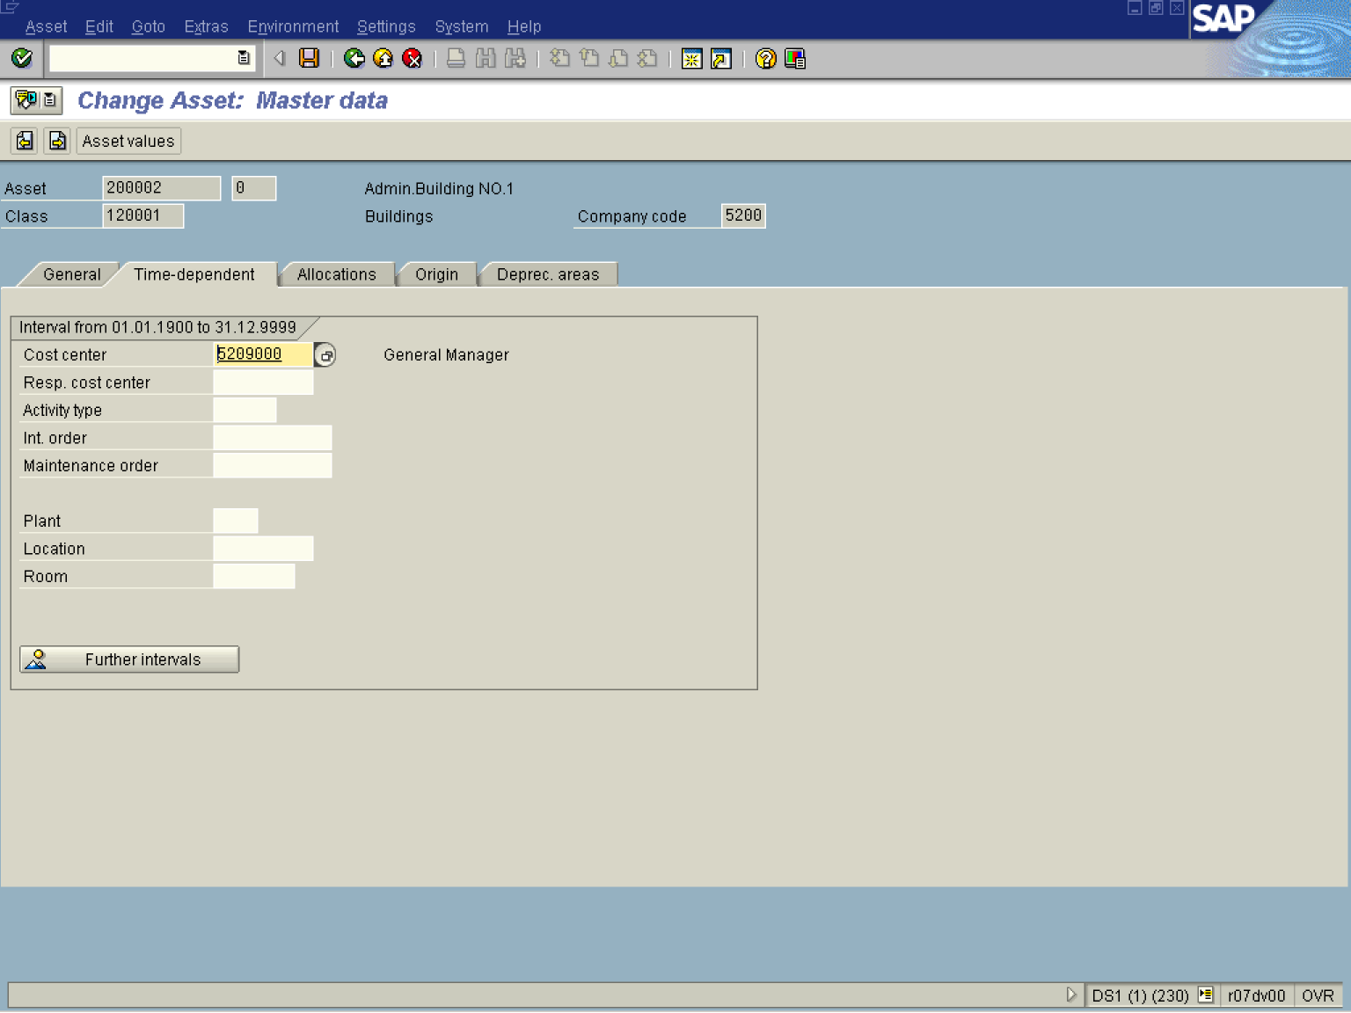

7. Press [F4] or Click the Search button in the Cost center field.
.

Restrict value range (1)

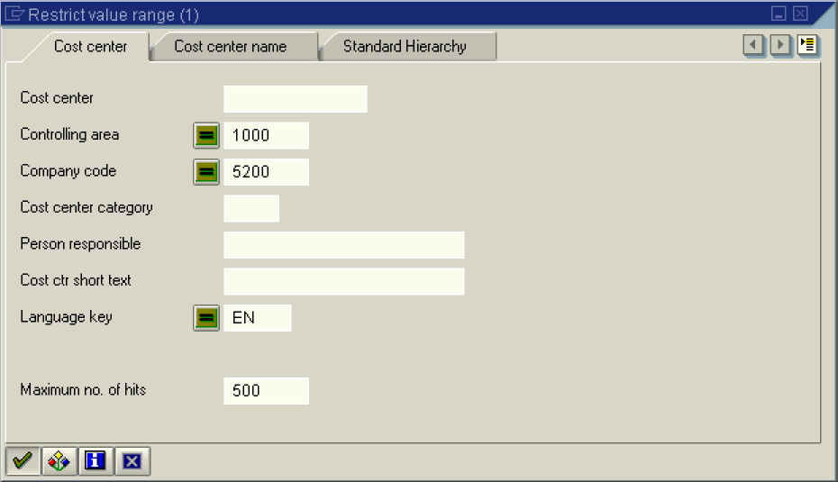
8. Select 5210000 - 1000 - 5200 - W - R. C. Allen - GENERAL ACCOUNTING - EN - 01.01.1900 - 31.12.2001 in list box.

Change Asset: Master data

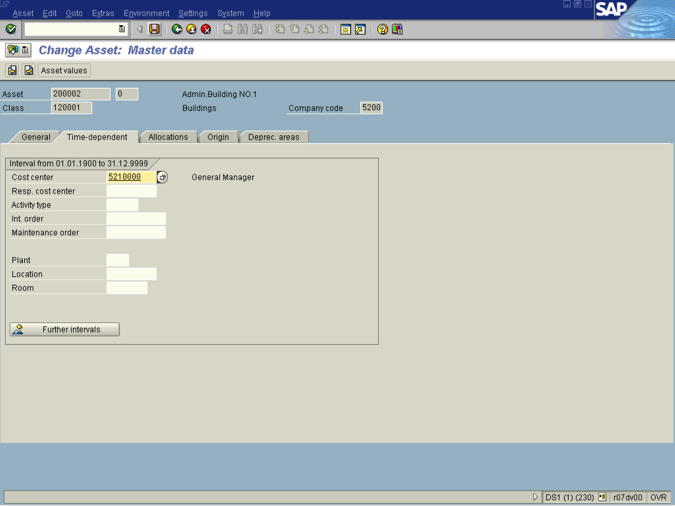
9. Click the Save button.
Is entered data for new or old interval?

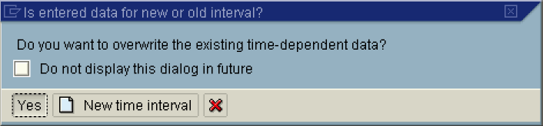

10. Click Yes Button .

Change Asset: Initial screen

